YISHUN JUNIOR COLLEGE

PRELIMINARY EXAMINATION

CHEMISTRY 8872/01
Higher 1
50 minutes

Paper 1 Multiple Choice

Additional materials: ORS

Data Booklet

YISHUN JUNIOR COLLEGE YISHUN JUNIOR COLLEGE YISHUN JUNIOR COLLEGE YISHUN JUNIOR COLLEGE YISHUN JUNIOR COLLEGE
YISHUN JUNIOR COLLEGE YISHUN JUNIOR COLLEGE YISHUN JUNIOR COLLEGE YISHUN JUNIOR COLLEGE YISHUN JUNIOR COLLEGE
YISHUN JUNIOR COLLEGE YISHUN JUNIOR COLLEGE YISHUN JUNIOR COLLEGE YISHUN JUNIOR COLLEGE YISHUN JUNIOR COLLEGE
YISHUN JUNIOR COLLEGE YISHUN JUNIOR COLLEGE YISHUN JUNIOR COLLEGE YISHUN JUNIOR COLLEGE YISHUN JUNIOR COLLEGE
YISHUN JUNIOR COLLEGE YISHUN JUNIOR COLLEGE YISHUN JUNIOR COLLEGE YISHUN JUNIOR COLLEGE YISHUN JUNIOR COLLEGE
YISHUN JUNIOR COLLEGE YISHUN JUNIOR COLLEGE YISHUN JUNIOR COLLEGE YISHUN JUNIOR COLLEGE YISHUN JUNIOR COLLEGE
YISHUN JUNIOR COLLEGE YISHUN JUNIOR COLLEGE YISHUN JUNIOR COLLEGE YISHUN JUNIOR COLLEGE YISHUN JUNIOR COLLEGE
YISHUN JUNIOR COLLEGE YISHUN JUNIOR COLLEGE YISHUN JUNIOR COLLEGE YISHUN JUNIOR COLLEGE YISHUN JUNIOR COLLEGE
YISHUN JUNIOR COLLEGE YISHUN JUNIOR COLLEGE YISHUN JUNIOR COLLEGE YISHUN JUNIOR COLLEGE YISHUN JUNIOR COLLEGE
YISHUN JUNIOR COLLEGE YISHUN JUNIOR COLLEGE YISHUN JUNIOR COLLEGE YISHUN JUNIOR COLLEGE YISHUN JUNIOR COLLEGE
YISHUN JUNIOR COLLEGE YISHUN JUNIOR COLLEGE YISHUN JUNIOR COLLEGE YISHUN JUNIOR COLLEGE YISHUN JUNIOR COLLEGE
YISHUN JUNIOR COLLEGE YISHUN JUNIOR COLLEGE YISHUN JUNIOR COLLEGE YISHUN JUNIOR COLLEGE YISHUN JUNIOR COLLEGE
YISHUN JUNIOR COLLEGE YISHUN JUNIOR COLLEGE YISHUN JUNIOR COLLEGE YISHUN JUNIOR COLLEGE YISHUN JUNIOR COLLEGE
YISHUN JUNIOR COLLEGE YISHUN JUNIOR COLLEGE YISHUN JUNIOR COLLEGE YISHUN JUNIOR COLLEGE YISHUN JUNIOR COLLEGE
YISHUN JUNIOR COLLEGE YISHUN JUNIOR COLLEGE YISHUN JUNIOR COLLEGE YISHUN JUNIOR COLLEGE YISHUN JUNIOR COLLEGE
YISHUN JUNIOR COLLEGE YISHUN JUNIOR COLLEGE YISHUN JUNIOR COLLEGE YISHUN JUNIOR COLLEGE YISHUN JUNIOR COLLEGE
YISHUN JUNIOR COLLEGE YISHUN JUNIOR COLLEGE YISHUN JUNIOR COLLEGE YISHUN JUNIOR COLLEGE YISHUN JUNIOR COLLEGE
YISHUN JUNIOR COLLEGE YISHUN JUNIOR COLLEGE YISHUN JUNIOR COLLEGE YISHUN JUNIOR COLLEGE YISHUN JUNIOR COLLEGE
YISHUN JUNIOR COLLEGE YISHUN JUNIOR COLLEGE YISHUN JUNIOR COLLEGE YISHUN JUNIOR COLLEGE YISHUN JUNIOR COLLEGE


READ THESE INSTRUCTIONS FIRST

Write in soft pencil.
Do not use staples, paper clips, highlighters, glue or correction fluid.
Write your name and CTG on the ORS form and shade your register number.

There are 30 questions on this paper. Answer all questions. For each question there are
4 possible answers A, B, C and D.
Choose the one you consider correct and record your choice in soft pencil on the ORS.

Read the instructions on the Answer Sheet very carefully.

Each correct answer will score one mark. A mark will not be deducted for a wrong answer. Any rough working should be done in this question paper.

This question paper consists of 15 printed pages

Section A
For each question there are four possible answers, A, B, C, and D. Choose the one you consider to be correct.

1 | Chromium is obtained from the following reaction, 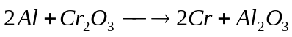. Calculate the percentage yield of chromium when 180 g of chromium is obtained from a reaction between 100 g of aluminium and 400 g of chromium(III) oxide.
 | A | 45.0%
 | B | 36.0%
 | C | 93.6%
 | D | 131%

2 | When 10 cm³ of a gaseous hydrocarbon was exploded with 100 cm³ of oxygen, the residual gas occupied 70 cm³. After shaking these residual gases with aqueous sodium hydroxide, the final volume was 20 cm³. All volumes were measured at room temperature and pressure. Calculate the molecular formula of the hydrocarbon.
 | A | C₅H₁₀
 | B | C₅H₁₂
 | C | C₇H₁₂
 | D | C₇H₁₄

3 | In which one of the following is a redox reaction?
 | A | CuO + H₂SO₄ → CuSO₄ + H₂O
 | B | C₂H₅CH₂OH + Na → C₂H₅CH₂ONa + H₂
 | C | NH₃ + HCl → NH₄Cl
 | D | Al₂Cl₆ → 2AlCl₃
x
4 | A plasma is a gaseous mixture in which the atoms have been completely stripped of their electrons, leaving bare nuclei. Predict the identity of x, y and z.
 |  | x | y | z
 | A | H | He | Be
 | B | Be | H | He
 | C | He | Be | H
 | D | Be | He | H
-
y
z
Source
+

5 | The successive ionisation energies, in kJ mol⁻¹, of an element X are given below.  870 1800 3000 3600 5800 7000 13200  What is the number of valence electron(s) in the outermost shell of element X?
 | A | 4
 | B | 5
 | C | 6
 | D | 7

6 | Which of the following does not have a macromolecular structure?
 | A | Diamond
 | B | Graphite
 | C | Silicon dioxide
 | D | Sodium chloride
7 | In which of the following pairs does the first species have a larger bond angle than the second?
 | A | NH₃, BF₃
 | B | SO₃²⁻, SO₄²⁻
 | C | ClO₃⁻, BrO₃⁻
 | D | H₂O, H₃O⁺
8 | Which one of the following equations is used to define the first ionisation of bromine?
 | A | Br(g) + e⁻ → Br⁻(g)
 | B | ½Br₂(g) + e⁻ → Br⁻(g)
 | C | Br(g) → Br⁺(g) + e⁻
 | D | ½Br₂(g) → Br⁺(g) + e⁻

9 | Consider the energy cycle below involving calcium fluoride  CaF₂(s) Ca²⁺(aq) + 2F⁻(aq)  Ca(s) + F₂(g)  Using the following data, calculate ΔH_{r}.  enthalpy change of formation of Ca²⁺ = -543 kJ mol⁻¹  enthalpy change of formation of F⁻ = -333 kJ mol⁻¹  enthalpy change of formation of CaF₂ = -1220 kJ mol⁻¹
 | A | -11 kJ mol⁻¹
 | B | +11 kJ mol⁻¹
 | C | -344 kJ mol⁻¹
 | D | +344 kJ mol⁻¹

ΔH_{r}

10 | The table shows some data on two acid-base indicators.  Identify the colour change of a weakly acidic solution in the presence of each indicator.
  Indicator | Approximate pH range | Colour change
  Indicator | Approximate pH range | acid | alkali
  Bromocresol green | 3.8 – 5.5 | yellow | blue
  Phenol red | 6.8 – 8.5 | yellow | red
 |  | Bromocresol green | Phenol red
 | A | Yellow | Yellow
 | B | Yellow | Red
 | C | Blue | Yellow
 | D | Blue | Red

11 | Given the following reaction in a vessel:  A_{(g)} + B_{(g)} 2C_{(g)} + D_{(g)} ∆H^{θ} < 0  Which of the following statement is correct?
 | A | Add a suitable catalyst and solvent to dissolve C will lead to an increase in rate of reaction and yield.
 | B | Increase temperature and increase pressure will lead to an increase in rate of reaction and yield.
 | C | Decrease the temperature and increase the pressure will lead to a decrease in rate of reaction and increase in yield.
 | D | Add a suitable catalyst and increase the pressure will lead to a decrease in rate of reaction but no change in yield.
12 | Which of the following does not describe K_{w}, ionic product of water.
 | A | It has units mol²dm⁻⁶
 | B | It increases when temperature increases
 | C | It has a numerical value of 1.0 x 10⁻¹⁴ at 25ºC
 | D | It is the equilibrium constant for the reaction where water breaks down to its elements.

13 | The radioactive decay of uranium-238 is the rate determining step in a series of changes in which lead is the final product formed. The radioactive decay is a first order reaction with a half-life of 4.5 x 10⁹ years.  What is the age of a rock sample (originally lead free) with uranium to lead ratio of 1:7 now?
 | A | 1.5 x 10⁹ years
 | B | 2.25 x 10⁹ years
 | C | 9.0 x 10⁹ years
 | D | 13.5 x 10⁹ years
14 | Which one of the following graphs shows how the rate of reaction changes with time for an autocatalytic reaction (i.e. a reaction catalysed by one of the products in the reaction)?
 | A | 0  time  Rate | C | Rate  0  time
 | B | Rate  0  time | D | Rate  0  time

15 | A mixture of the oxides of two elements of the third period is dissolved in water. The solution is approximately neutral.  What could be the constituents of the mixture?
 | A | Al₂O₃ and MgO | C | Na₂O and MgO
 | B | Na₂O and P₄O₁₀ | D | SO₃ and P₄O₁₀
16 | The element antimony occurs in Group V of the Periodic Table. Which one of the following sets of oxidation numbers is antimony likely to show in its compounds?
 | A | + 3 only | C | + 3 and + 5
 | B | + 5 only | D | + 4 and + 5
17 | The following graph shows the boiling points of eight consecutive elements, (i) to (vii), in Periods 2 and 3 of the Periodic Table.  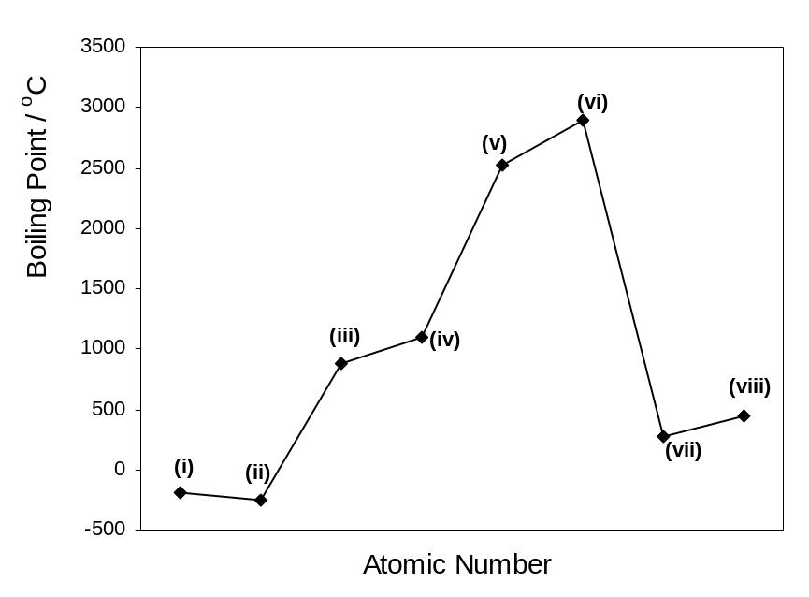  Which one of the following statements about the oxides of the elements is INCORRECT?
 | A | (i) forms an oxide with a melting point of 1286°C.
 | B | (v) forms an oxide which can react with bases.
 | C | (vi) forms a solid oxide.
 | D | (viii) can form an oxide with variable oxidation states.

18 | The anti-asthma drug Intal contains disodium cromoglycate, which has the following structure.  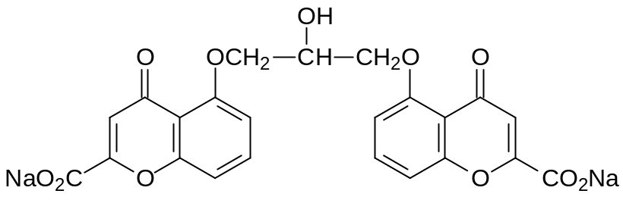  What is the total number of sp³ and sp² hydridized carbons in an Intal molecule?
 |  | sp³ | sp²
 | A | 3 | 20
 | B | 20 | 3
 | C | 18 | 5
 | D | 5 | 18
19 | The diagram below shows the structure of a catalytic converter as fitted into the exhaust system of a car.  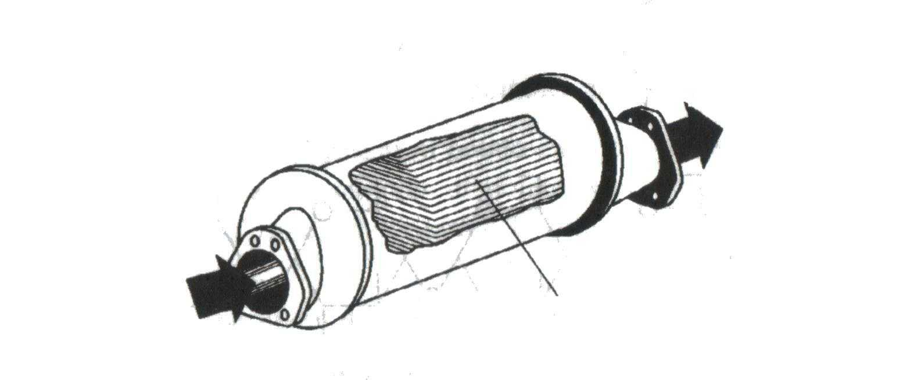  Which of the following reactions could take place of the surface of the catalyst?
I | hydrocarbons + oxides of nitrogen → carbon dioxide + water + nitrogen
II | carbon monoxide + oxides of nitrogen → carbon dioxide + nitrogen
III | carbon monoxide + hydrocarbons → carbon dioxide + water

 | A | I, II and III
 | B | I and II only
 | C | II and III only
 | D | I and III only
Gases in
Gases out
surfaces coated with platinum and rhodium catalyst

20 | Why does the reaction C₂H₅X + OH⁻ → C₂H₅OH + X⁻ occur faster if X is iodine instead of bromine?
 | A | The I⁻ ion is less hydrated in water than the Br⁻ ion.
 | B | The C – Br bond is more polar than the C – I bond.
 | C | The C – Br bond is stronger than the C – I bond.
 | D | The overlapping of C – Br orbitals is less effective than the C – I overlap.
21 | Which set of alcohols correctly shows a primary, a secondary and a tertiary alchol?
 |  | primary | secondary | tertiary
 | A | 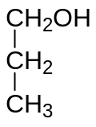 | 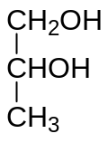 | 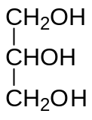
 | B | 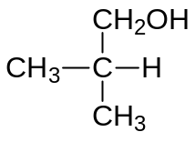 | 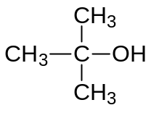 | 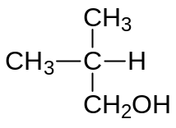
 | C | 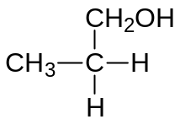 | 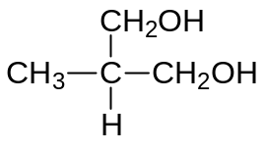 | 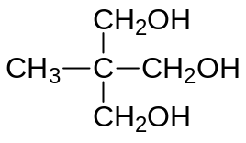
 | D | 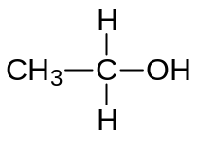 | 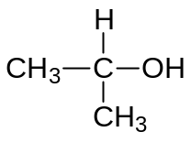

22 | Which one of the following alcohols will give the greatest number of different alkenes when treated with concentrated sulphuric acid?
 | A | 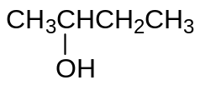
 | B | 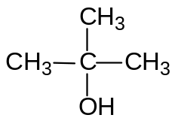
 | C | CH₃CH₂CH₂CH₂OH
 | D | 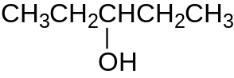
23 | The oxo reaction is an important industrial process in which an alkene combines directly with carbon monoxide and hydrogen under suitable conditions. The reaction with ethene is shown below.  CH₂=CH₂ + CO + H₂ → CH₃CH₂CHO  Which of the following structural formulae correctly represents the product of the oxo reaction starting with but-2-ene?
 | A | CH₃CH₂CH(CH₃)CHO
 | B | CH₃CH₂CH₂CH₂CHO
 | C | CH₃CH₂COCH₂CH₃
 | D | (CH₃)₂CHCH₂CHO
Catalyst

High T, p

24 | The Russian composer Borodin was also a research chemist who discovered a reaction in which two ethanal molecules combine to form a compound commonly known as aldol (reaction I). Aldol forms another compound on heating (reaction II).  Which of the following best describes reaction I and II?
  I | 2CH₃CHO → CH₃CH(OH)CH₂CHO
  II | CH₃CH(OH)CH₂CHO → CH₃CH=CHCHO + H₂O
 |  | I | II
 | A | addition | reduction
 | B | addition | elimination
 | C | elimination | reduction
 | D | substitution | elimination

25 | Which compound reacts with its own oxidation product (an oxidation which involves no loss of carbon) to give a sweet-smelling liquid?
 | A | propanal
 | B | propanoic acid
 | C | propanone
 | D | propan-1-ol

Section B

For each of the questions in this section, one or more of the three numbered statements 1 to 3 may be correct.

Decide whether each of the statements is or is not correct (you may find it helpful to place a tick against the statements that you consider to be correct).

The responses A to D should be selected on the basis of

A | B | C | D
1, 2 and 3 are correct | 1 and 2 only are correct | 2 and 3 only are correct | 1 only is correct

No other combination of statements is used as a correct response.

26 | Magnesium has a lower first ionisation than beryllium.  Which statements help to explain this?
 | 1 | the nuclear charge of magnesium is higher than beryllium.
 | 2 | the electron to be ionised from magnesium is further from the nucleus than that in beryllium
 | 3 | Magnesium has more electron shells than beryllium.

27 | Which of the following describes the strength of a metallic bond?
 | 1 | The larger the size of the metal ion(cation), the stronger is the metallic bond.
 | 2 | The greater the charge of the metal ion(cation), the stronger is the metallic bond.
 | 3 | The greater the number of valence electrons the metal has, the stronger is the metallic bond.

The responses A to D should be selected on the basis of

A | B | C | D
1, 2 and 3 are correct | 1 and 2 only are correct | 2 and 3 only are correct | 1 only is correct

No other combination of statements is used as a correct response.

28 | Which of the following reactions are always exothermic?
 | 1 | CO(g) + ½ O₂ (g) → CO₂ (g)
 | 2 | K⁺ (g) + Cl ⁻ (g) → KCl (s)
 | 3 | 2NaOH (aq) + H₂SO₄ (aq) → Na₂SO₄ (aq) + 2 H₂O (l)

29 | Which of the following react at a reasonable rate with chlorine at room temperature with sunlight but in the absence of a catalyst?
 | 1 | methane
 | 2 | ethene
 | 3 | methylbenzene

The responses A to D should be selected on the basis of

A | B | C | D
1, 2 and 3 are correct | 1 and 2 only are correct | 2 and 3 only are correct | 1 only is correct

No other combination of statements is used as a correct response.

30 | Chlorofluorocarbons (CFCs) pose environmental problems in that they cause the depletion of the ozone layer. Hydrochlorofluorocarbons (HCFCs) are alternatives which help to reduce the problem. The ozone depletion potential values of a CFC and a HCFC are given below.  Which of the following could account for the difference in ODP?
   | Ozone Depletion Potential (ODP)
  CFCl₃ (CFC) | 1.0
  CF₃CHCl₂ (HCFC) | 0.10
 | 1 | The C–F and C–H bonds are stronger than C–Cl bond.
 | 2 | The concentration of Cl from CFCl₃ is higher than that from CF₃CHCl₂, therefore the rate of depletion of ozone is faster.
 | 3 | Flourine atom is very stable while chlorine atom is very reactive.

